# Project Title: Flower recognition

## Group members: Rimple Poonia Dabas, Sakshi Dalal, Sweta Joshi

## Aim: Flask based App to identify type of flower from an uploaded image

### Data Collection:

* Google Images: Web scraping (Selenium and Chromedriver)
* Flickr: API (good API call limit 3600 queries per hour), used flickrapi python package
* Pixabay: API (100 requests per minute limit)

### Data cleaning

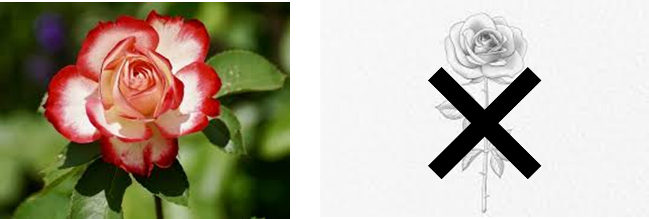 Combining images and getting rid of junk images (manually)

### Model

Model

Pre processing steps

Training steps

Testing Steps

Performance

Accuracy and loss

Classification Report

Confusion Matrix

Validation

### Flask app

* App Routes:

@app.route("/", methods=['GET', 'POST'])

@app.route("/about")

@app.route("/upload", methods = ['GET', 'POST'])

### JavaScript CSS and HTML

* Event listeners (click, button, drag drop, results)
* Take help for designing from inspecting web pages.

**HTML layout**

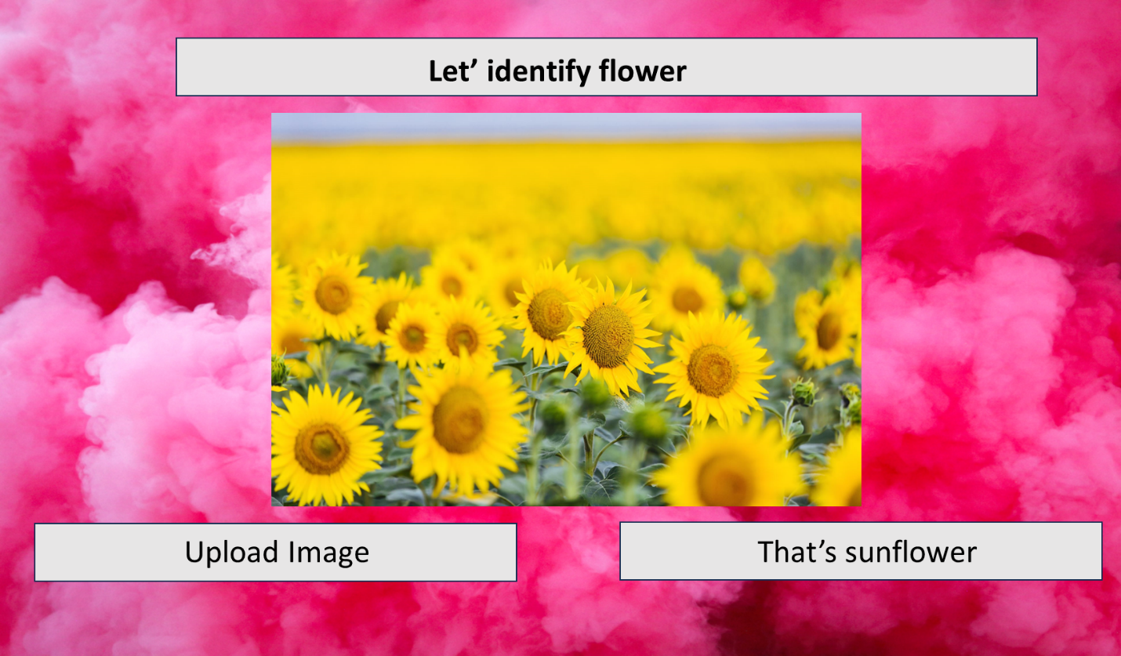

|  |  |  |  |
| --- | --- | --- | --- |
|  | Work Breakdown Structure |  |  |
| Task | Member responsible | Delivery  Date | Status |
| Data collection | Everybody | 17 July | Done |
| Data cleaning | Everybody | 21 July | Done |
| Model  (Training, Testing, and validating) | Everybody  (Choose the best one) | 26 July |  |
| Flask App | JavaScript (Sweta), HTML(Rimple), CSS(Sakshi), Flask code (All) | 30 July |  |
| Combining  Work | Everybody | 1 Aug |  |
| Read me markdown | Rimple | 2 Aug |  |